sudo apt-get install git

sudo apt-get -y install git python3-pip python3-dev

python3 --version

pip3 --version

sudo apt-get -y install python3-eventlet python3-routes python3-webob python3-paramiko

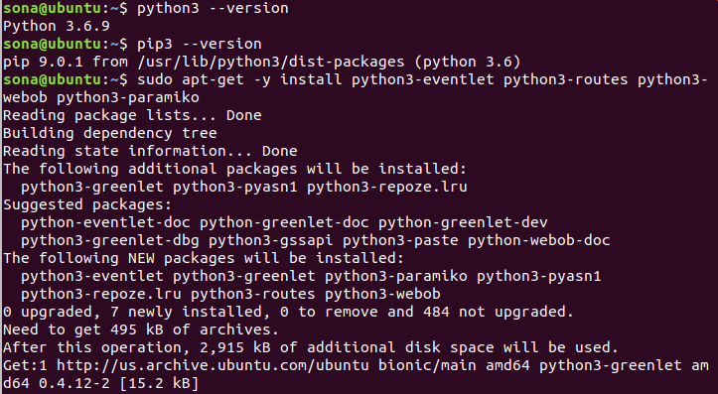

mkdir sdn

cd sdn/

git clone --depth=1 <https://github.com/osrg/ryu.git>

cd ryu/

sudo pip3 install setuptools --upgrade

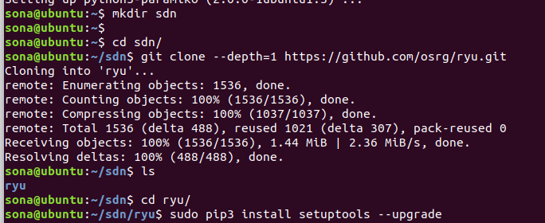

sudo python3 ./setup.py install

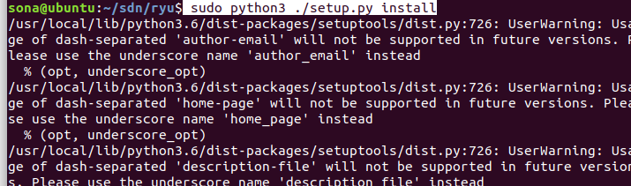

sudo pip3 install six --upgrade

sudo pip3 install oslo.config msgpack-python

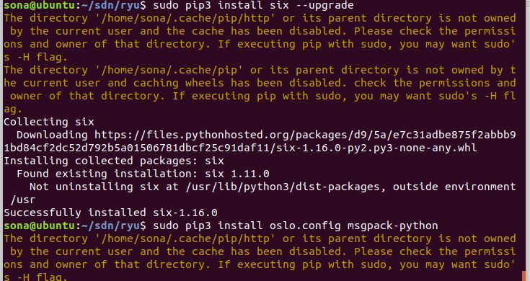

sudo pip3 install eventlet --upgrade

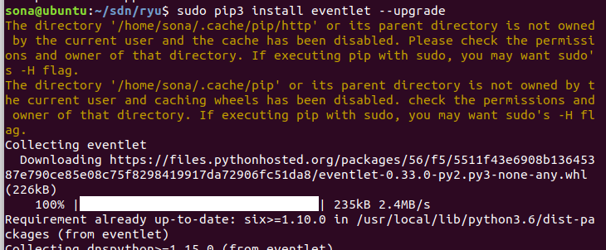

sudo pip3 install -r tools/pip-requires

sudo python3 setup.py install ( Do if you are not able to view ryu-manager)

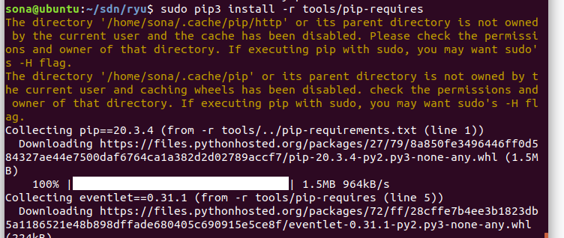

ryu-manager --version



ryu-manager --observe-links ryu.app.simple_switch ryu.app.gui_topology.gui_topology

Ryu is running now dont close the terminal.

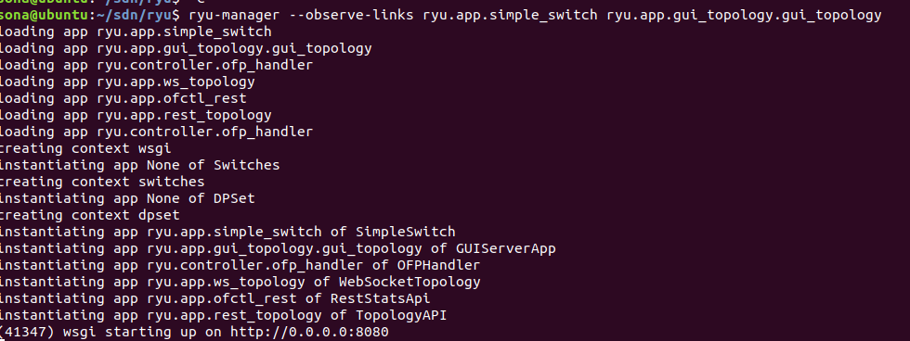

Now steps for mininet

**step 1: download VM** [**https://github.com/mininet/mininet/releases/**](https://github.com/mininet/mininet/releases/)

**Step 2: Open OVF file in the workstation.**

**Open new terminal in ubuntu**

ssh -X mininet@192.168.142.130

Above IP address is of mininet

if the authority error exists then type

ssh -o UserKnownHostsFile=/dev/null -o StrictHostKeyChecking=no -X mininet@192.168.142.130

sudo mn --controller=remote,ip=192.168.142.131 --topo tree,depth=3

In above command ip is of ubuntu machine you can get by command ip r ( do in new terminal to get the ip)

OPEN HTTP :http://0.0.0.0:8080

